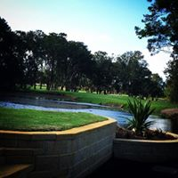
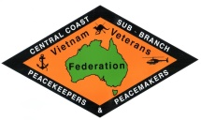

Monday, 23rd November 2026
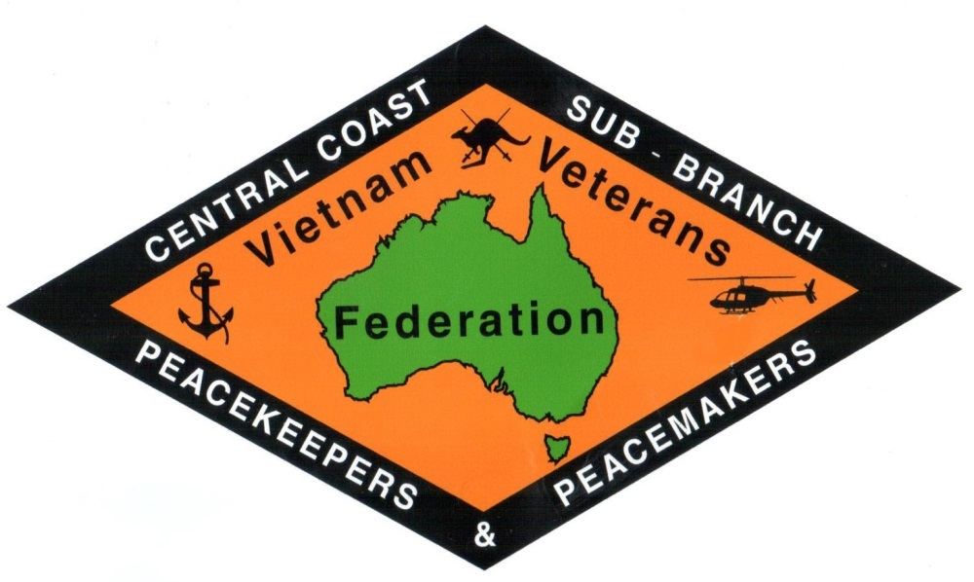
CHARITY GOLF DAY
Venue: Everglades Country Club – Dunban Road, Woy Woy.

Event: 18 Hole - Three Person Ambrose

Timings: 6.30am Breakfast
7.30am Shotgun Start

Cost: $700 Corporate Sponsorship - includes Team Entry (3 Players)
- Sponsorship of a hole, great exposure and promotional opportunities (Sponsorship motifs to be supplied by sponsor)
- Breakfast & Lunch.

Proceeds of the day go to supporting the Central Coast Vietnam Veterans, Peacekeepers and Peacemakers in providing services to current serving and ex-serving members of the Australian Defence Force and their Families

Entries & Enquiries to:-
Vietnam Veterans’ P & P Association of Australia C.C.S.B. Phone: 43444760
32 Broken Bay Road, ETTALONG BEACH 2257
Email: centralcoastveterans@bigpond.com Web: https://ccveterans.org.au/

OR
Everglades Pro Shop Phone/Fax: 43413399

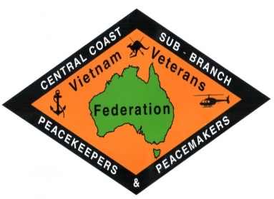
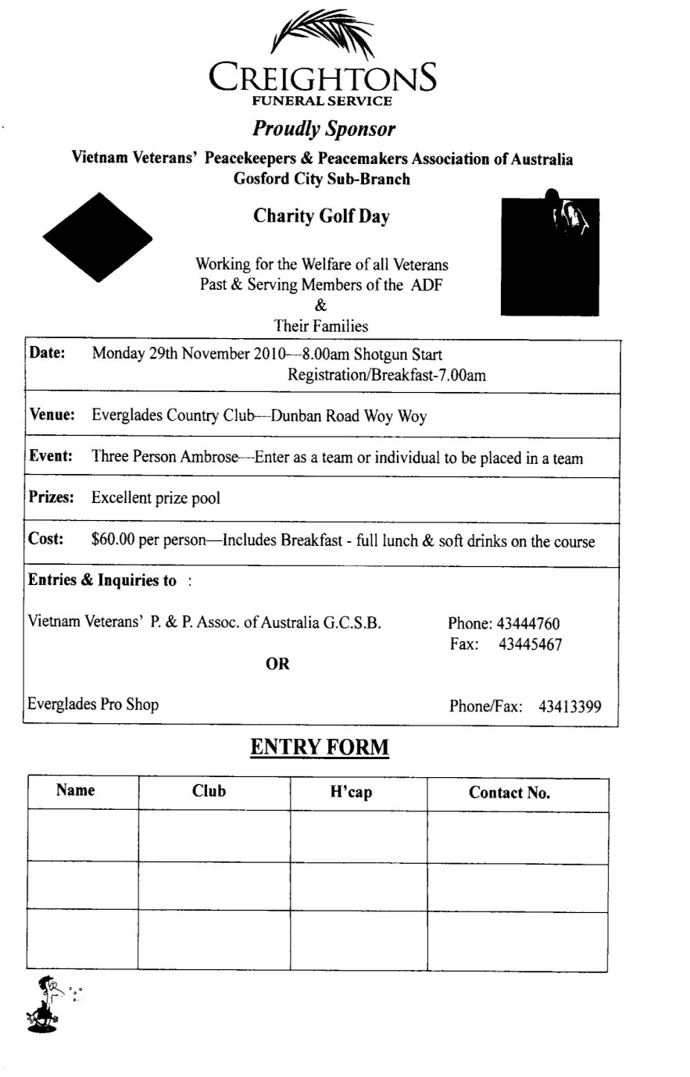

Proudly Sponsor
Vietnam Veterans’, Peacekeepers & Peacemakers’ Association of Australia
Central Coast Sub-Branch Inc.
Date: Monday 23rd November, 2026 6.30am - Registration/Breakfast
7.30am - Shotgun Start

Venue: Everglades Country Club – Dunban Road, Woy Woy.
Event: Three Person Ambrose –Enter as a team, or individual to be placed in a team.
Prizes: Excellent prize pool Raffles: Excellent Value
Cost: $700 Corporate Sponsorship - includes Team Entry (3 Players)
- Sponsorship of a hole, great exposure and promotional opportunities. (sponsorship motifs to be supplied by sponsor)
- Breakfast & Lunch
Individual $100 per person – includes Breakfast & Lunch and 18 holes of fun golf.
Drinks are available from the Half-Way House behind 1st green.

Entries & Enquiries to:-
Vietnam Veterans’, P & P Association of Australia C.C.S.B. Phone: 43444760
Email: centralcoastveterans@bigpond.com Web: https://ccveterans.org.au/
OR
Everglades Pro Shop Phone/Fax: 43413399

CHARITY GOLF DAY

ENTRY FORM: Name | Club | H’Cap | Contact No.

IF A PLAYER HAS NO AGU HANDICAP THEIR HANDICAP WILL BE 18

ALL NON-GOLFERS WELCOME TO LUNCH at $35 pp (please notify our Office or Pro Shop)

