Proudly Sponsor - 2026 Charity Golf Day
on
MONDAY 23rd November 2026
To be held at
Everglades Country Club
Dunban Road, Woy Woy
The day commences at 6.30am with Breakfast, then a Shotgun tee-off at 7.30am to commence a Three Person Ambrose Event. $100 per player. Alcohol will be available from the Kiosk between the 1st green and 10th tee.
A lunch is also provided and includes a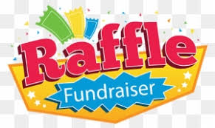containing a huge range of excellent prizes to be won.
Entries & Enquiries to: VVPPAA CCSB Phone: 4344 4760
Email: centralcoastveterans@bigpond.com
OR
Everglades Pro Shop Phone/Fax: 4341 3399
Web site: https://ccveterans.org.au
Entry forms and further details can be found on our web site above.

COME ALONG & ENJOY THE FU N 

